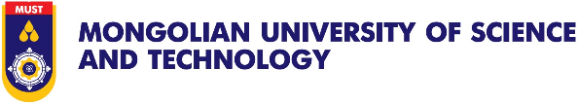

APPLICATION FORM

LEGO-TNE Project – Student’s exchange mobility from MUST to UNICT

Project: “LEGO Italy-East Asia Cooperation: from Local Expertise to a Global Outlook”
Host Institution: University of Catania (Italy)
Sending Institution: Mongolian University of Science and Technology (Mongolia)
APPLICATION’S DETAILS
First name: | Last name:
Date of birth: (dd/mm/yyyy) | City and Country of birth:
Nationality: | Gender: (Male / Female)
Home Address: (full address)

Passport number: | Date of Expiry: (dd/mm/yyyy)
Mobile number: | E-mail Address:

HOME UNIVERSITY: Mongolian University of Science and Technology (MUST), Mongolia
Department/School:
Major/degree:

Compulsory documents:
Check | Documents
 | Application Form: Duly completed and signed by the applicant
 | Curriculum Vitae (CV): Detailing academic achievements, qualifications and extra-circular activities, and volunteer experience relevant to international projects
 | Certificate of Employment: An official certificate issued by the sending institution conforming the applicant’s current student status and his/her mobility involvement can include teaching/training in English.
 | Language Proficiency: Copies of official language certifications such as IELTS, TOEFL
 | Identification: A clear copy of a valid passport
 | Applications to prepare a project/study/research hours and topics which will then be assessed by the selection board

All of the above documents are necessary to complete the application.
SIGNATURE OF APPLICANT
I confirm that the information provided on this application form is correct.
Signature: | Place and Date:

